## Speech doorbell

## 1. Purpose

In this lesson, we will learn how to use micro:bit to drive the speech synthesis module and button module to realize the speech doorbell function.

**2. Programming method**

Mode 1 online programming:

First, we need to connect the micro:bit to the computer by USB cable. The computer will pop up a USB flash drive and click on the URL in the USB flash drive: http://microbit.org/ to enter the programming interface. Add the Yahboom package: https://github.com/YahboomTechnology/Speech and <https://github.com/lzty634158/Croco-Kit> to start programming.

Mode 2 offline programming:

We need to open the offline programming software. After the installation is complete, enter the programming interface, click[New Project]. Add Yahboom package: <https://github.com/YahboomTechnology/Speech> and <https://github.com/lzty634158/Croco-Kit>, you can start programming.

**3. About wiring**

The I2C communication used by this module.

|  |  |
| --- | --- |
| Button Module | Micro:bit board |
| OUT | 1 |
| VCC | 5V/3.3V |
| GND | GND |

|  |  |
| --- | --- |
| Speech synthesis module | Micro:bit board |
| SCL | 19 |
| SDA | 20 |
| VCC | 5V/3.3V |
| GND | GND |

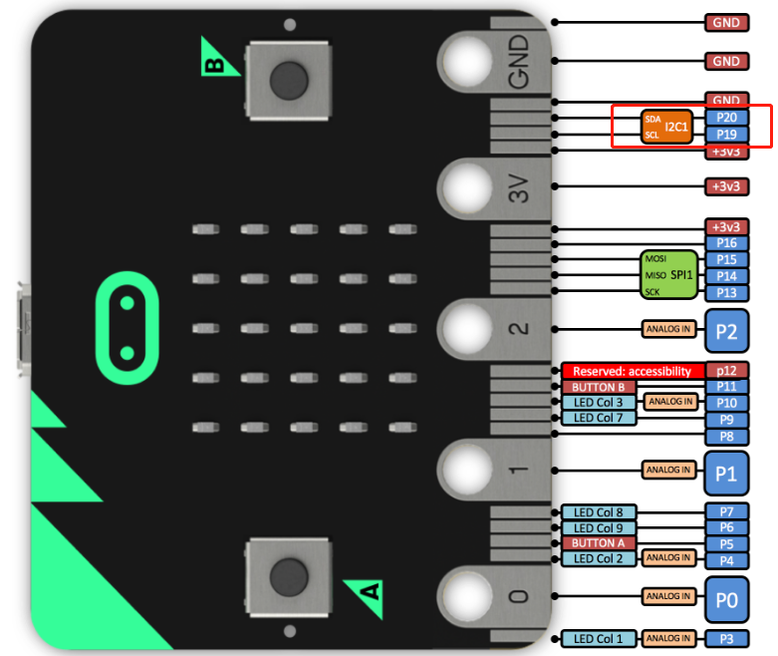

1. **Combine building blocks**

In addition to the programming building blocks for speech synthesis, we also need to use the building blocks for button module in the Crocokit expansion package.

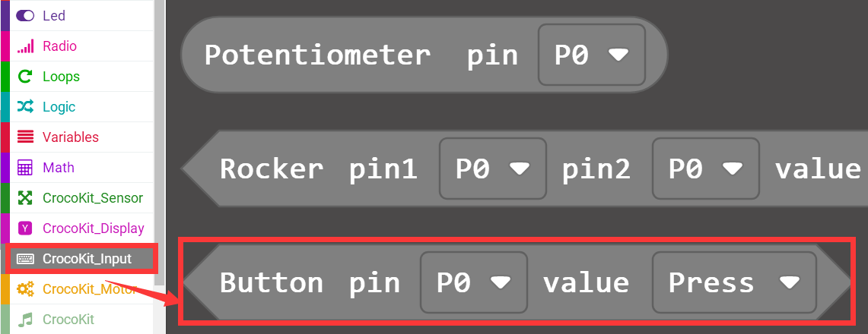

1. **Combine building blocks**

The summary program is shown below:

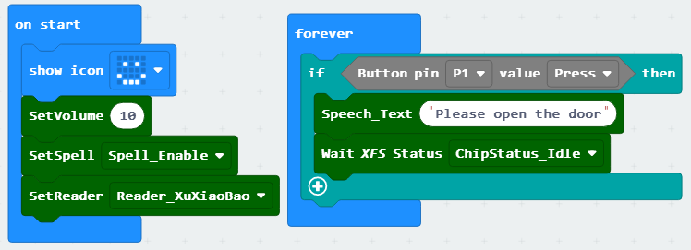

After broadcasting the finally content, we need to call and wait for the chip state to return to the idle state before adding other content.

Before the broadcast of the current text is completed, if you call the voice broadcast building block, the broadcast of the current content will be interrupted when other content is broadcast.

**6. Experimental phenomenon**

After the program is downloaded successfully, micro:bit will display a smile face.

When we press button module, speech synthesis module will play “Please open the door!”.